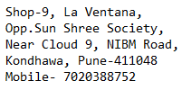

Inward Challan No: IT-0000

**Name: -**  **Mobile: -**

**Email ID: -**  **Machine Inward Time: -**

**Machine Details**

**Machine Type: - Brand: -**

**Model No: - Serial No: -**

**Ram: - 8Gb**

**HDD: - 320GB**

**Battery: - Yes**

**Adapter: -Yes**

**CPU: -**

**Fan: -**

**Machine Problem: -**

**Any Other Description: -**

**Terms and Conditions:**

* All Material’s received are subject to verification
* We aim to repair the fault as described by the customer and to return the laptop to its original working order where possible.
* If further issues or faults are found while working on your laptop we will notify the you before continuing with the repair. No claim will be entertained in this regard.
* We are the sole judge for the repair or replacement of faulty spares.
* Estimate of the repair will be given for the repairs to the customer on phone.
* Estimate may change if more spares are required to up the faulty material that additional estimate cost will give to the customer on phone.
* After estimate given, customer should revert back for yes or no within 1 day.
* After taking the estimate customer will get approximate of delivery.
* Delivery date may change without prior notice as per the availability of spares.
* After taking the estimate if customer does not want to repair the material then he will be charge for minimum Rs. 500 for diagnostic efforts.
* Customer will be sole responsible for any other problem occurred while repairing the faulty material. Material given for repairs will be on customer’s risk.
* We take no responsibility of working / Non-working of any spares of material & data loss during the repairing.
* 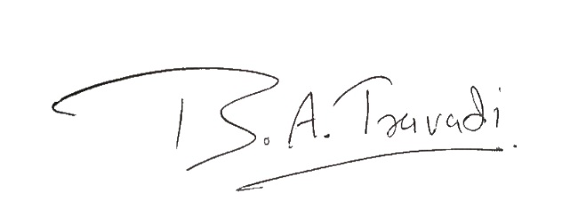We have a 30 days’ warranty of our service specific to the problem repaired. No warranty on Software installation.
* During the repairing time we are not taking any data backup, data backup extra charges will be applicable.

**Signature: -**

**For receiver ____________________________ For Customer ______________________________**

**Signature, Signature,**

**Thank you for being with us,**

**Best Regards,**

**IT Buddy**